Name: Nicky Wijaya Suhendra
Student ID: 1820262219

Saturday, 17 October 2026
Time: 12.00-13.00
During the short period between classes, me and 3 other available team member (Niel, Devon, and Darren) meet up in the dorm basement B1 to set up git on their device and discuss the plan for this project. We have set up the repository the previous Friday during CS & AI Class.
What was done:
-Helped to set up git and SSH connection for my teammate on both Windows and MacOS.
-Fixed the repository name we made up on the place during class.
-Gain the general idea of the project by discussing and reading lexue.
AI Used:
-Used AI to learn how to set up git on MacOS and Windows.
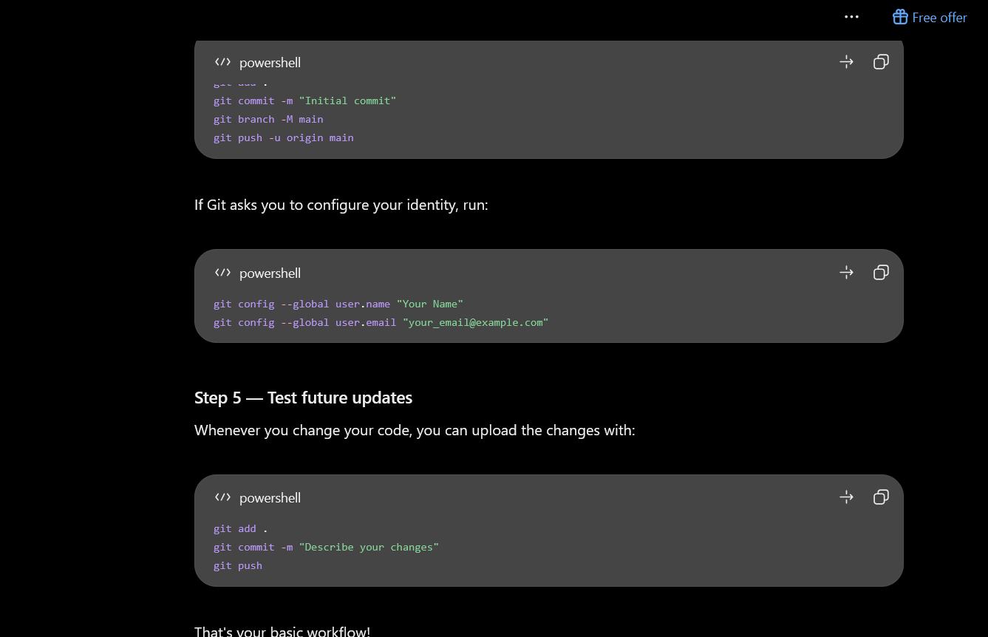

Lessons learned:
-Learnt that setting up git is different in different OS and should have learnt them earlier instead of relying on Linux.
Next Steps:
-Follow up the information from this meeting to the other members.
-Set up git for the rest of the members.
-Brainstorm ideas and make up a plan for this project.

Time: 19.00-21.00
First formal meeting with my teammate, deciding topics, repository structure, etc
This is the first formal meeting with my teammate held in one of the dorm room. In this meeting, I coordinated the required task and separate the responsibilities to each of the members. I followed up the previous meeting so the members are up to date to the info and set up git for the rest of the members.

What was done:
-Followed up the previous unofficial meeting information to the rest of the members.
-set up git for the rest of the members.
-Separated the task into smaller chucks so the rest of the members can understand their responsibilities.
-Monitored the member works while I set up the repository and explain them.
AI Used:
-None
Lessons learned:
- Understood the importance of planning strategies to improve the quality and effectiveness of the project.
-Realized that discussion and brainstorming can help the teams productivity.
Next Steps:
-Continue to monitor the work done in the shared docx file.
-learn and research the application of algorithm and connectionist AI
-Optimize the repository and overhaul README.MD

Tuesday, 20 October 2026 (18.00-21.00)
After my team started working for the past few days, I started overhauling the repository to match the criteria listed on lexue. I filled in README.MD after my teammate created the skeleton for the markdown. My teammate have been pushing changes to the master branch, so I fixed it and changed and synced it to main.
What was done:
-Overhauled the repository to match lexue’s criteria.
-Filled README.MD to match the criteria (90% filled)
-Fixed push path from master branch to main.
-coordinated better instructions and answering questions my teammate had for the projects.
-Fully understands the project requirement with the help of AI.

AI Used:
-To Comprehend the project requirement
-To study how to merge branches.
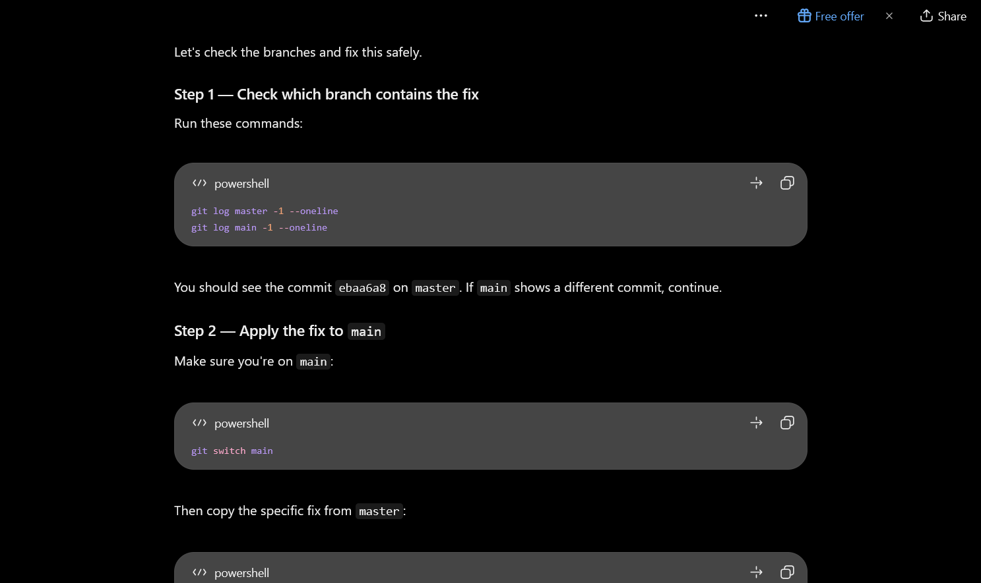
Lessons learned:
-Learnt markdown notations and how to apply it.
-Learnt how to organize a repository.
-Learnt how to change and merge branches.
Next Steps:
-Continue to monitor the work done in the shared docx file.
-learn and research the application of algorithm and connectionist AI.
-Set up a personal Log.
-Remind my team to set up their own personal log and meeting logs.

Tuesday, 21 October 2026 (21.00-23.00)
After class, I set up the required personal logs and sent reminders and instruction on how to complete the submission 1 task.
What was done:
-Created a personal Log with the help of previous year works.
-Discussed what AI Algorithm to explain for the study module in WeChat (Undecided).
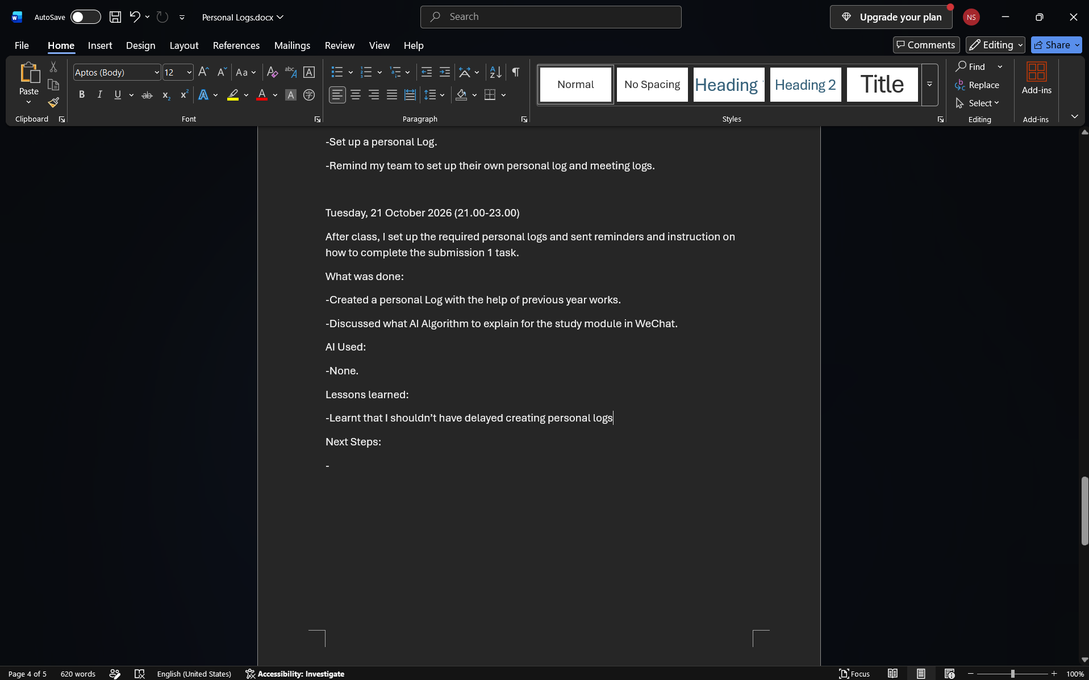
AI Used:
-None.
Lessons learned:
-Learnt that I shouldn’t have delayed creating personal logs
-Learnt that I should have documented more for the personal and Meeting Logs.
Next Steps:
-Decide Which Algorithm to use and explain for the learning module.
-Clean up the messy repository.
-Continue updating personal Logs.
-Learn and research the application of algorithm and connectionist AI.
-Continue monitoring and coordinating the project progress.

